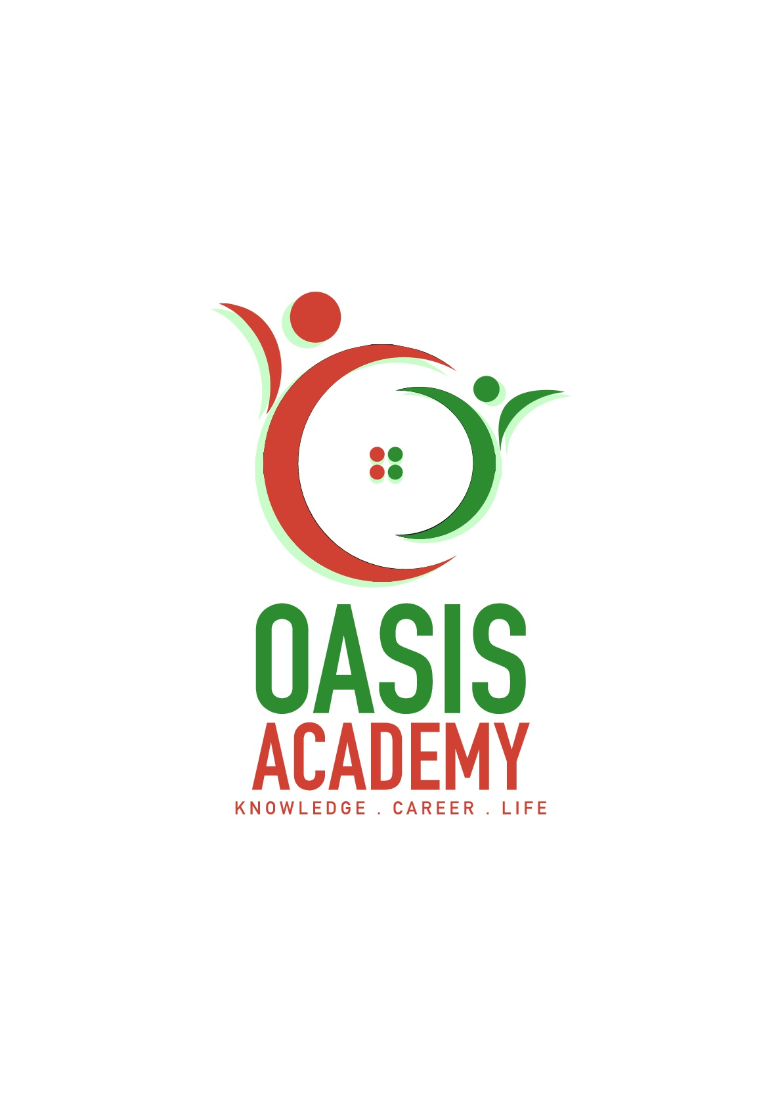

Name: Ugeswari Karuppiah

Login ID: ugeswari@oasis-portal.com

Course title: Tourism and Hospitality

Subject Code: BHM04

Submitted date: 11/9/17

**Table of Contents**

|  |  |  |
| --- | --- | --- |
| **No** | **Details** | **Page** |
| 1 | Executive Summary | 2 |
| 2 | Introduction | 3 |
| 3 | Assignment Question |  |
|  | Part 1 | 4-9 |
|  | Part 2 | 10-16 |
|  | Part 3 | 17-19 |
|  | Part 4 | 20-21 |
| 4 | Conclusion | 22 |
| 5 | References | 23 |
|  | Appendix | - |

**Executive Summary**

In the module, I understand the topic about tourism and hospitality. In the first part of the assignment, we can see the introduction of tourism and hospitality. What is the tourism and hospitality and how important is the hospitality industry? In the first part of the question, I define of tourism and hospitality management and will explain about the importance, also in general. The brief understanding about the hospitality and tourism industry. Through this part I have covered the overall understanding about hospitality and tourism industry.

**Introduction**

In this chapter provides a fresh introduction Hospitality and Tourism is often described as 'the pleasure industry' or 'the welcome industry'. It’s an industry where communication is the key feature. It’s also an international industry and will involve a range of inter-cultural encounters. The language of this industry is quite clearly English in an international context, but it is also the language of meeting needs, of providing high levels of service, of understanding people, of delighting people, of solving problems. From a teaching point of view the emphasis is firmly on functional language giving information, making recommendations, dealing with problems and so on and on creating realistic situational practice where language functions can be demonstrated and developed alongside basic service-oriented performance. Tourism and Hospitality industries are major growth industries globally and play an important role in the economies of developed and emerging countries. These industries generate substantial employment, personal and corporate income, tax revenues, foreign exchange earnings, investments, and infrastructure improvements for communities in developed and developing countries globally. These economic factors influence many opportunities that require a combination of management, marketing, operational and organizational skills, as well as a sound knowledge and understanding of the overall Industry, it's interrelationships and it's services. Hospitality professionals generally work in administrative or management positions in a service-based environment, and they are responsible for overseeing the operations and success of an establishment, such as a hotel or restaurant. The hospitality and tourism industry is diverse, and includes many locations including RV parks, food establishments, recreational facilities, campgrounds, boarding houses and youth hostels. While the overall goal of a hospitality professional is to ensure that guests and customers have pleasurable experiences, they can also be responsible for operations, such as hiring and training new staff; supervising office and financial administration; housekeeping, maintenance, and security staff; and marketing. The types and forms of business organizations are also covered here. At the end of all the lessons is a summary knowledge of the topic discussed.

**Assignment Question**

**Question 1**

**Define the tourism and hospitality**

The hospitality and tourism industry includes lodging, travel and tourism, recreation, amusements, attractions, resorts and food beverage service. hospitality professional is to ensure that guests and customers have pleasurable experiences, they can also be responsible for operations, such as hiring and training new staff; supervising office and financial administration; housekeeping, maintenance, and security staff; and marketing. Hospitality professionals also distribute funds, set room rates, and ensure that the service standards of the business are met. General duties for hospitality professionals vary depending on the size of the business and the amount of staff available. In larger operations, there is usually a hierarchy of general managers, assistant managers, and supervisors who work to perform operational tasks relating to their areas of expertise. In a smaller business, the hospitality professional performs these tasks directly. Sometimes hospitality professional positions are specialized. For example, some focus on managing the front office, while others can be responsible for convention services or financial administration. If a hospitality professional is employed in a specialized position, he or she must have excellent communication skills and the ability to work well alongside coworkers in other areas of the business.

**Tourism**

The activities of people travelling to staying in place outside their usual environment for leisure, business, out of comfort zone or other purpose for not more than one consecutive years.

**Tourism important**

Tourism has become an important sector that has an impact on development of country economy. The main benefits to tourism are income creation and generation of jobs. For many regions and countries, it is best most important source of welfare. The consumption of goods and services by tourists. Tourism industry is also one of the influential sectors. It generates employment opportunities. It provides employment to unskilled, semi-skilled and skilled manpower. Guide, load man etc. are the personal or labor required in Tourism industry. Tourism system Tourism industry is the source of income for both public also well as private sector government charges tax, sales tax, service tax etc. which is known as government revenue is the income of public. And handicraft, arts etc. are the things that attract tourist and most of them buy them and the seller makers some profit which is called private income. Tourism industry facilities cultural exchange tourist carry over various cultural concepts of other countries where they visit. Local people can learn their language, art, skill, and culture.

**Tourism system**

The Tourism System goes beyond a mere description of tourism and its basic principles. It incorporates concepts, principles, and theories from disciplines such as psychology, economics and marketing that greatly influence tourism.

**Figure1: created by leiper in 1990**

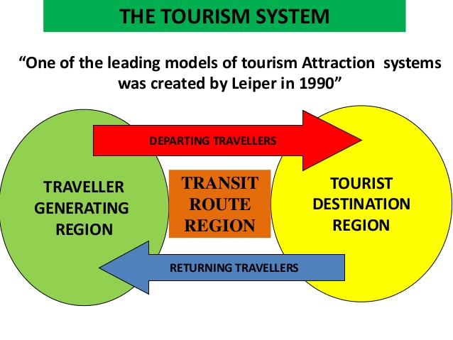

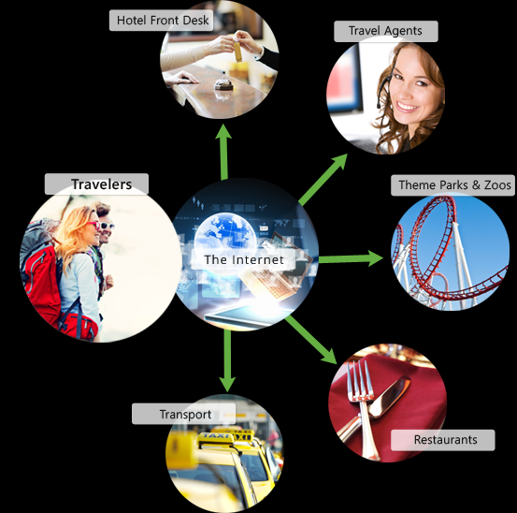

**Figure2:** GOTO Plus a revolution in online travel services.

**The main activity of tourism**

Activity Tourism covers a range of areas from “active” holidays involving leisure, climbing, horse-riding and mountaineering, to the less physical, yet still activity-focused areas of nature watching, food trails, or local culture and heritage trails and for business also with an increased focus on healthier living, activity tourism is an area that has been growing strongly over the last 20 years.

**Hospitality defined**

Hospitality refer to the relationship between a guest and a host, wherein the host receives the guest with goodwill, including the reception and entertainment of guests, visitor or strangers.

**Define tourism and hospitality**

Tourism and hospitality consist of lodging, travel and tourism, recreation amusements, attractions resort, restaurants and food beverage services. The hospitality industry is a broad category of fields within services industry that includes lodging, event planning, theme parks, transportation, cruise line and additional fields within the tourism industry.

**Travel and Tourism Industry**

The hospitality industry is part of a larger enterprise known as the travel and tourism industry. This industry is a vast group business with one goal in common: that is to provide necessary or desired products and services to travelers. Travel and tourism industry has now become the largest civilian industry in the world, according to statistics one out of every ten person worldwide is part of the Travel and tourism industry. Travel and Tourism industry are divided into five major parts as shown below . Lodging operations stands apart from other travel and tourism business as they offer overnight stay for the guests.

**Lodging**

Under lodging operations comes Hotels, Motels, Resorts, Inns, Serviced apartments, Timeshare Hotels, Condominiums, Conference Centers, B&B, Casinos Etc. Lodging operations is the largest sector under Travel and Tourism Industry.

**Transportation Services**

Ships, Air planes, Autos, Bus, Railways, Metro's, Bikes, Limousines all comes under the Transportation Services in the Travel and tourism industry.

**Food and Beverage**

Restaurant, Lodging Properties Retail stores, Vending Machines, Catering, Snack Bars, Cruise Ships, Bars, Banquets, Out Door Catering All Comes under the F&B operations sector.

**Retail Stores**

Gift Shops, Souvenir shops, Handicraft Shops, Art Shops, Markets etc.

**Activities**

Recreation, Businesses, Entertainment, Amusement Parks, Study Trips, Sporting Events, Ethnic Festivals Etc.

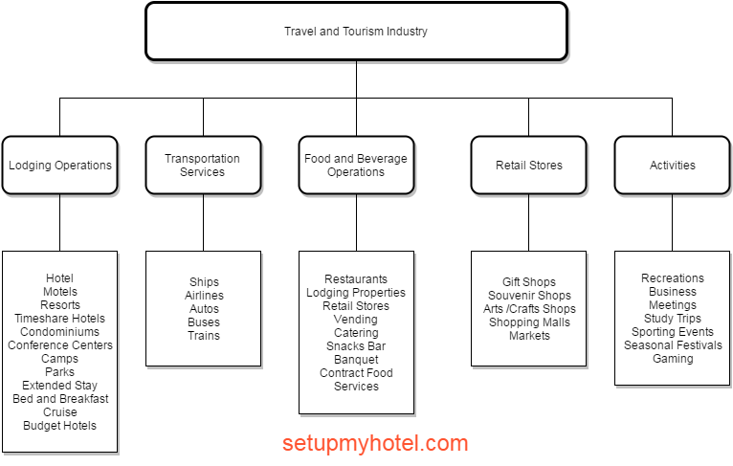

**Figure 3;setupmyhotel**

**Question 2**

**Brief on different type of tourism categories**

**Leisure tourism**.

This is when people go to a place that is very different from them orates aspects of recreation tourism where the patient goes to a relaxing getaway to recover from the procedure. Regular day-to-day life to relax and have fun. Beaches, theme parks and camp grounds are often the most common places frequented by recreational tourists.

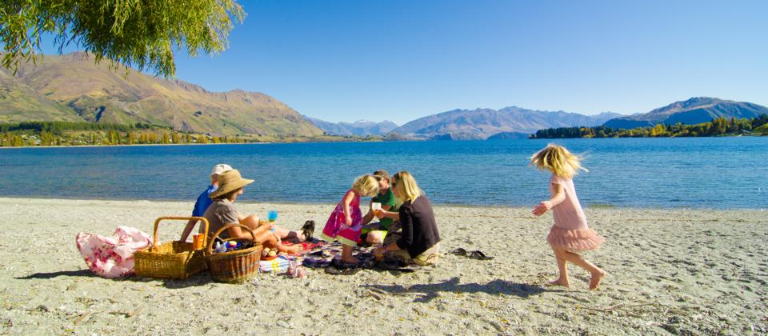

**Culture tourism**

If the objective of one’s visit to a place is to get to know its history and culture then this type of tourism is known as cultural tourism. Tourists may visit different landmarks of a country or they may simply opt to focus on just one area. They may also attend festivals and ceremonies to gain a better understanding of the people, their beliefs and their practices.

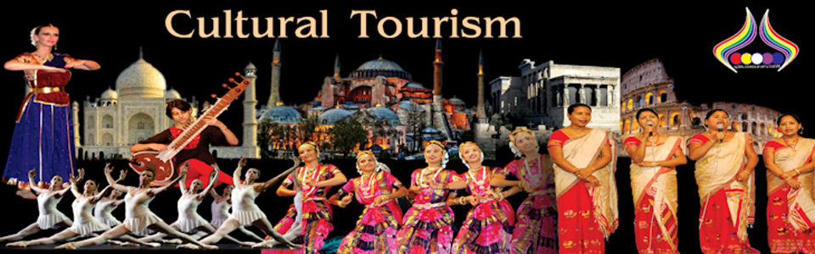

**Religious tourism**

The is another type of tourism where people go to a religious location or locations to follow the footsteps of

their founder or to attend a religious ceremony. Although Islam is the state religion of Malaysia, freedom of worship is guaranteed. The Malays are almost all Muslims. The Chinese embrace an eclectic brew of Taoism, Buddhism and ancestor worship though some are Christians. Although Christianity has made no significant inroads into Peninsular Malaysia, it has had a much greater impact in East Malaysia, where many indigenous people have converted to Christianity, although others still follow their animist traditions. With so many cultures co-existing in harmony within its shores, Malaysia naturally boasts a myriad of festivals celebrated throughout the year. The major festivals are Aidilfitri, Chinese New Year, Deepavali, Christmas, Vaisakhi, Gawai Dayak and Tadau Ka’amatan.During these festivals, Malaysians practice a concept called ‘open house’ an occasion to receive well-wishers. There will be feasting and merry-making as everyone partakes in the gaiety of the occasion. Malaysians of all races and religions join in the festivities.

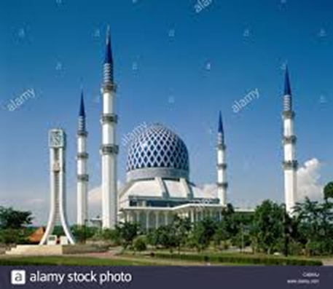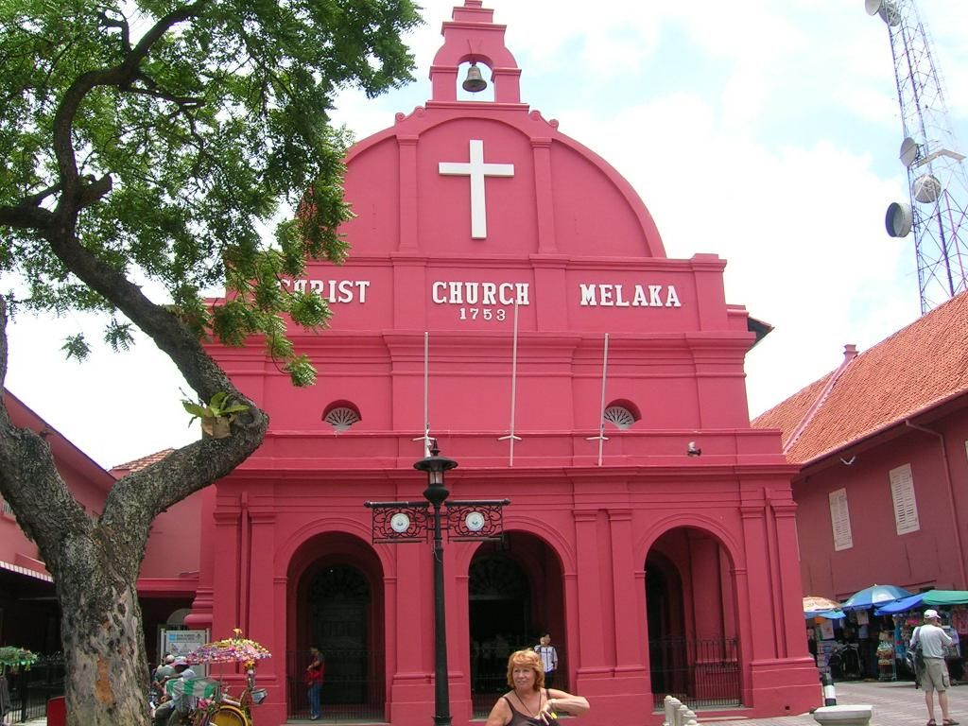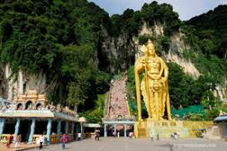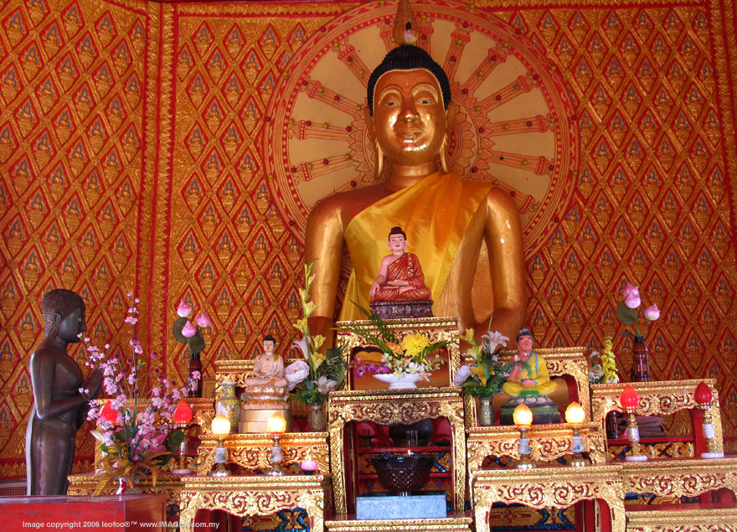

**Health tourism**

the is a relatively new type of tourist activity where the focus of the travel is improving one’s health, physical appearance or fitness. For instance, certain countries promote the expertise of their doctors and surgeons in the field of cosmetic surgery and invite foreigners to have their liposuction, facelift, nose lift and other forms of cosmetic procedures to be done there. Medical tourism also ecoadventure tourism is another type of tourism that is catered for those who want to do more than just visit regular tourist sites. These kinds of trips involve challenging activities like rock climbing, mountain climbing and wild water rafting.



**Family tourism**

Family tourism involves the family unit and their participation in diverse forms of tourism activity. This includes visiting one relatives and friends for interpersonal reason.

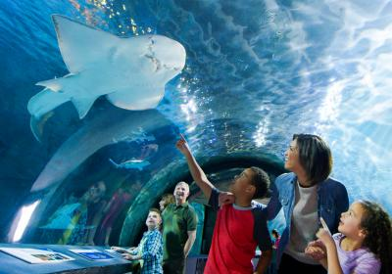

**Sports tourism**

Sport tourism is a fast-growing sector of the global travel industry. Sport tourism refers to people travelling to participate in a competitive sport event. Normally these kinds of events are the motivators that attract visitor to visit the events like Olympic games, FIFA world cup, sea game, according to the national tour association, adventure tourism is a “tour designed around an adventurous activity such as rafting, hiking or mountain climbing. “sports tourism is a package of recreation, enjoyment, education, thrill of participating in an adventure (land, water & aerial)

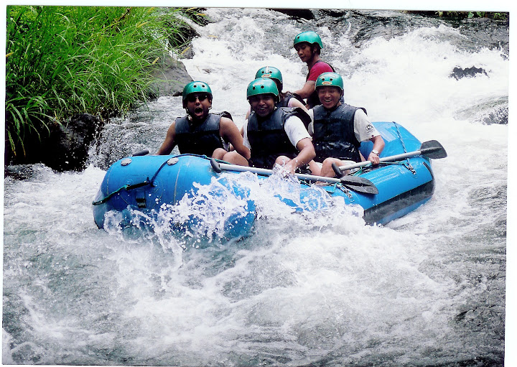

**Educational tourism**

Educational tourism is an increasingly popular new trend in the global tourism industry. According to scholars, the concept of a wide range of educational tourism, it has been changing the concept of tourism itself. Educational tourism is those people, including education and learning language, environment, and new culture is their main purpose of this trip to carry out tourism activities. In other words, the main purpose of travel is to obtain knowledge and experience on certain topics, rather than travel itself. Historically, we know that we have defined the initial educational travel tour starting today, excursions and discovery in the form of cruise. Tourism Education is Higher liquidity tourism or study, can be divided into two types, full-time study program or participate in international exchange programs.

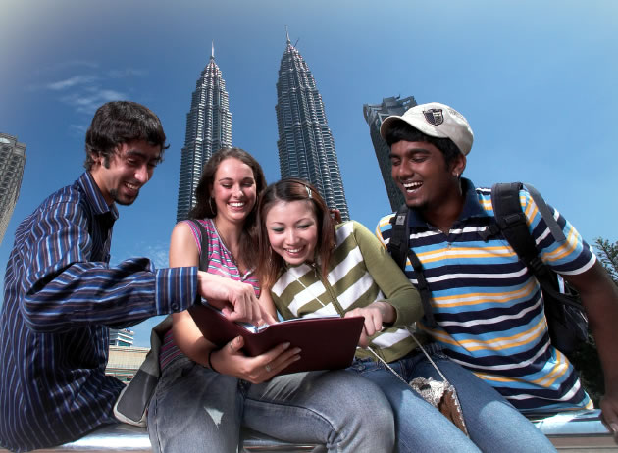

**Business tourism**

The business tourism travelers main motive for travel is work for long-term. Tourists visit particular destination for various pertaining to his work such as attending a business, meeting conference, conventions selling product and meeting clients. The business tourism is popularly called as MICE (meeting, incentives, conferences and exhibitions) tourism.

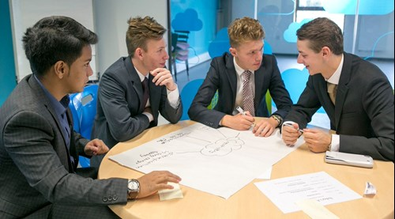

**Hospitality industry**

For tourism, the hospitality industry is a broad category of fields within services industry that includes lodging, event planning, theme parks, transportation, cruise line and hospitality unit such as restaurant and hotel.

**The tourism product**

The tourism product consists of the 6A’s are access, accommodation, attractions, actives, amenities and ancillary services.

*Access=Transportation*

*Accommodation=Places to stay overnight*

*Attractions=Natural or man-made*

*Activities=Festivals and events*

*Amenities=Essential facilities,(gym,swming pool)*

*Ancillary services=Extra services*

**Question 3**

Describe the lodging accommodation and type of hotel accommodation?

**Bed & Breakfast**

A Bed and Breakfast (B&B) is a private home in which guests can be accommodated at night in private bedrooms (which may or may not have private bathrooms. The owner or manager lives in the house or on the property. The public areas of the house, such as kitchen and lounge have either limited access for guests, or are shared with the host family to some degree. The business may be run as a secondary occupation. Breakfast is included in the price (generally either continental or full-English). Other meals may be available by arrangement.

**Backpacker Hostel**

A hostel (or backpacker) establishment is aimed at the budget traveler and generally attracts a younger clientele. Bedrooms are in a dormitory style (shared) and bathrooms are shared, although private bedrooms may be available. Light meals may be available in addition to the room rate.

**Boutique**

A boutique hotel is a 5-star establishment providing all the features and facilities of a normal hotel, in a unique and exclusive style Depending on size, location, and amenities. These properties are generally small, feature top class service and are marketed to the affluent.

**Guest House**

A guesthouse is generally a private home which has been converted for the dedicated and exclusive use of guest accommodation. The public areas of the establishment are for the exclusive use of the guests. The owner or manager either lives off-site, or in an entirely separate area within the property. A Guesthouse offers a wider range of services than a B&B, and usually caters for all meals.

**Hotel**

A hotel is generally the largest of all accommodation types, there is typically a common reception area, and rooms generally open directly onto a hallway. The on-site restaurant and other facilities are more accessible to the public than the other accommodation types. A wide range of guest services is available, such as room service. Hotels are often members of larger hotel groups, and a similar accommodation experience may be available in different establishments within the group.

**Lodge**

A lodge is an accommodation facility which is located and designed to optimize the feeling of being closely in touch with nature. The building style should feature natural materials and coloring such as wood, stone and thatch. An outdoor experience should be offered at the lodge, such as guided walks, game drives etc.

**Private Home**

A private home not dedicated for full time occupation of guests, but is a private house or apartment which is temporarily available for rental, often during peak tourism seasons.

**Resort**

A spread-out collection of single or double story accommodation units. Like a hotel in that it offers a wide range of facilities. Units may be rented and available on time-share. A camping area may be included in the resort.

**Self-Catering**

A self-catering establishment may be primarily one of the other accommodation types, but also offers dedicated self-catering facilities. The unit should feature a fully equipped kitchen to cater for the maximum people to be accommodated (including fridge, stove, cutlery, crockery, cooking utensils, cleaning equipment). The kitchen should be for the exclusive use of the guests, and not shared.

**Picture of hotel**

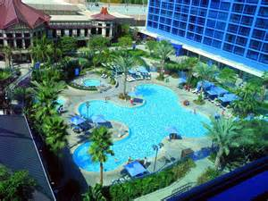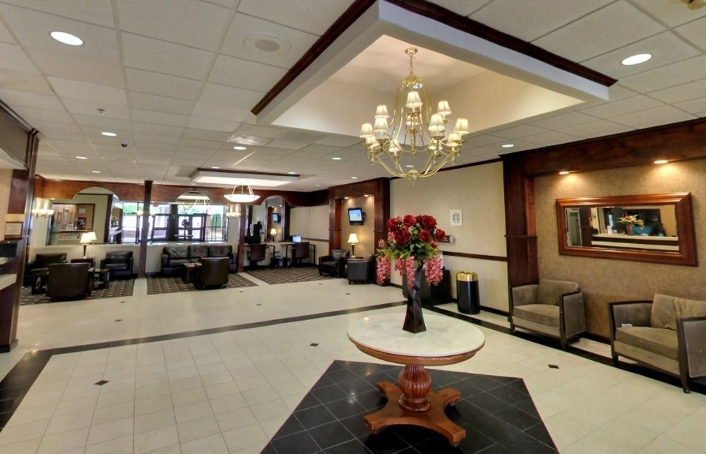

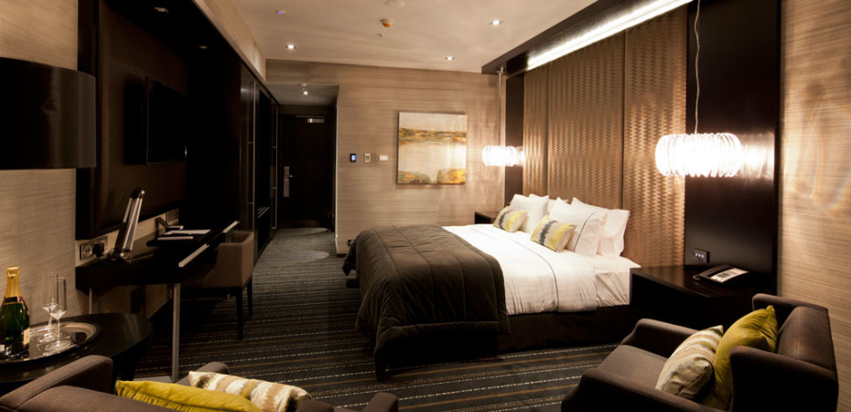

**QUESTION 4**

Explain the significant of entertainment in this industry?

The tourism industry is attractions, which offer visitors a chance to explore the sights, facilities and wonders of their destination. Attractions generally include historic sites, heritage homes, museums, halls of fame, art galleries, botanical gardens, ski hills, aquariums, zoos, water parks, amusement parks, casinos and cultural attractions. The Recreation and Entertainment industry includes myriad activities that range from bird watching and salmon fishing to horseback riding, whitewater rafting, golfing, wilderness trekking and educational visits to entertaining stops. Regardless of size, these venues need people to work in gift shops and restaurants, as well as help maintain the facilities, manage the operations and promote the attractions.

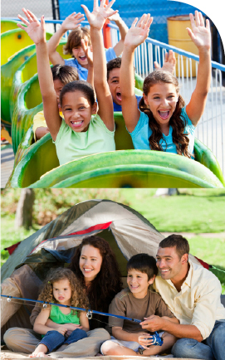

**Attractions**

Attractions are generally single units, individual sites or very small, easily delimited geographical areas based on a single key feature, Natural beauty such as beaches, tropical island resorts with coral reefs, hiking and camping in national parks, mountains and forests, are examples of traditional tourist attractions to spend summer vacations. Other examples of cultural tourist attractions include historical places, monuments, ancient temples, zoos, aquaria, museums and art galleries, botanical gardens, buildings and structures (e.g., castles, libraries, former prisons, skyscrapers, bridges), theme parks and carnivals, living history museums, ethnic enclave communities, historic trains and cultural events. Factory tours, industrial heritage, creative art and crafts workshops are the object of cultural niches like industrial tourism and creative tourism. Many tourist attractions are also landmarks.

**Shopping**

Shopping is an activity in which a customer browses the available goods or services presented by one or more retailers with the intent to purchase a suitable selection of them.

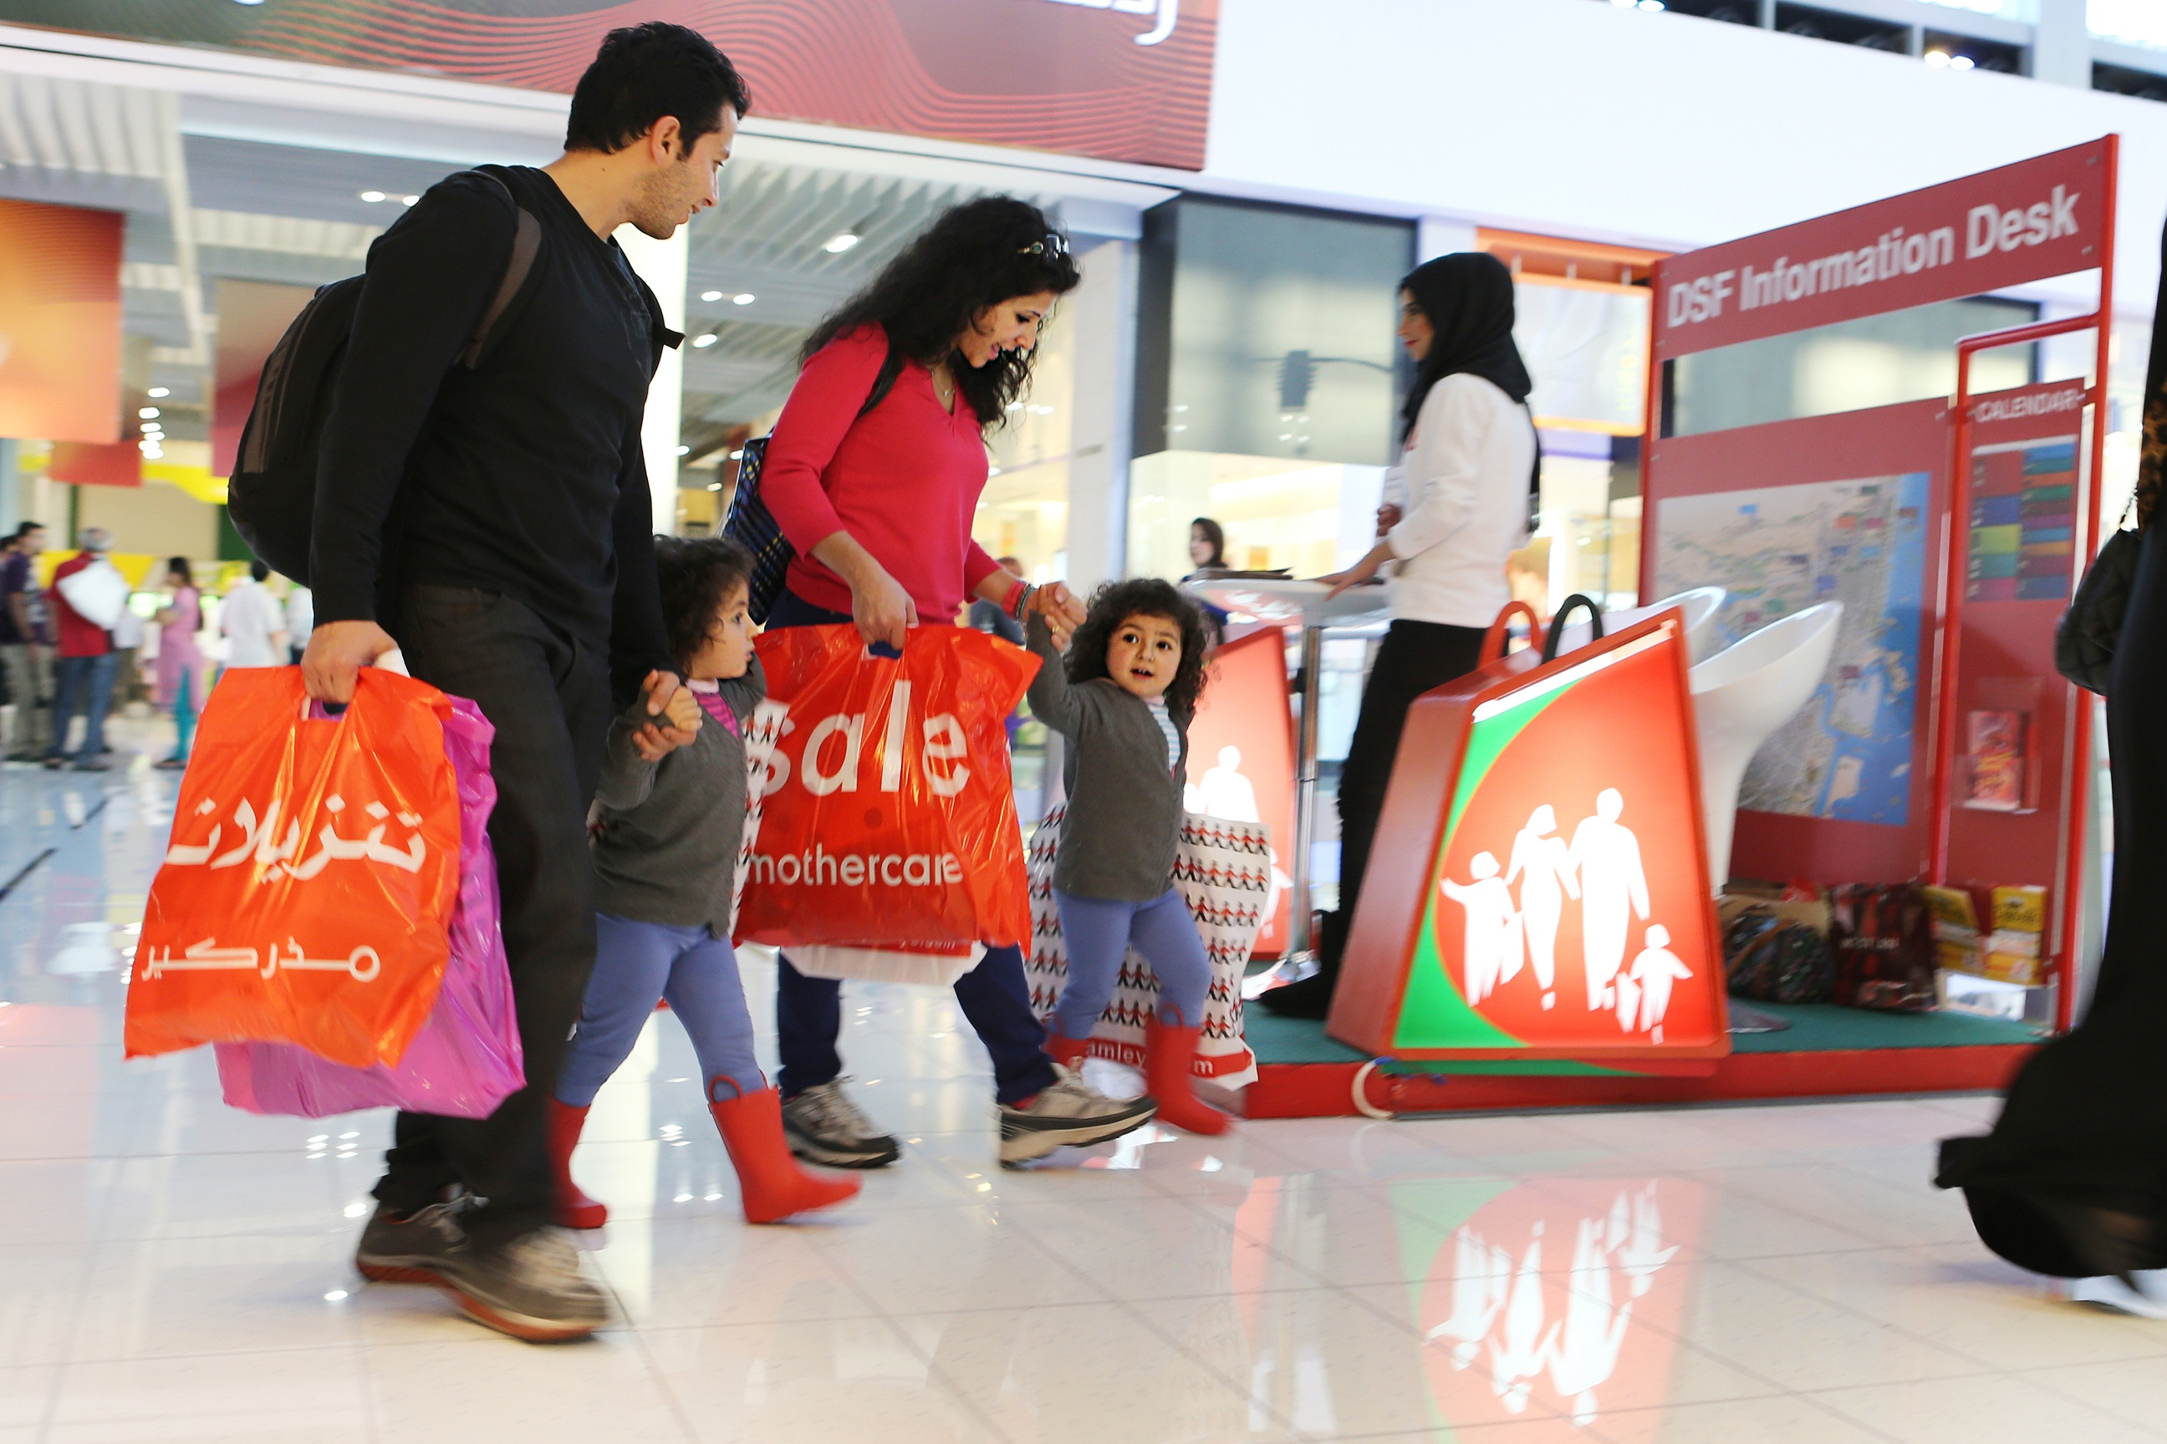

**Conclusion**

In the module, I understand the topic about hospitality and tourism, In the first part of the assignment, we can see introduction of tourism and hospitality often described as 'the pleasure industry' or 'the welcome industry'. It’s an industry where communication is the key feature. It’s also an international industry and will involve a range of inter-cultural encounters. what is the tourism and hospitality how importance to business. In the first question, I define tourism and hospitality. Tourism and Hospitality industries are major growth industries globally and play an important role in the economies of developed and emerging countries. These industries generate substantial employment, personal and corporate income, tax revenues, foreign exchange earnings, investments, and infrastructure improvements for communities in developed and developing countries globally. These economic factors influence many opportunities that require a combination of management, marketing, operational and organizational skills, as well as a sound knowledge and understanding of the overall Industry, it's interrelationships and its services. tourism and hospitality management and will explain about the importance, also in general. The brief understands about the hospitality and tourism. Through this part I have covered the overall understand hospitality and tourism industry.

**References**

1. <https://www.google.com/imgres?imgurl=https://image.slidesharecdn.com/got3module1-141222001616-conversion-gate01/95/whole-tourism-system-model-neil-leiper-4-638.jpg?cb%3D1419207514&imgrefurl=https://www.slideshare.net/Poddar25/got-3-module-1&h=479&w=638&tbnid=16dVztkTYj84RM:&tbnh=194&tbnw=259&usg=__aZc5h3y0KEXFa_bdW4FVW6iB578%3D&vet=1&docid=uACVmGHFwG2MMM>
2. <https://www.icms.edu.au/courses/subjects/Introduction-to-Hospitality-and-Tourism-Management>
3. <https://www.google.com/imgres?imgurl=https://image.slidesharecdn.com/got3module1-141222001616-conversion-gate01/95/whole-tourism-system-model-neil-leiper-4-638.jpg?cb%3D1419207514&imgrefurl=https://www.slideshare.net/Poddar25/got-3-module-1&h=479&w=638&tbnid=16dVztkTYj84RM:&tbnh=194&tbnw=259&usg=__aZc5h3y0KEXFa_bdW4FVW6iB578%3D&vet=1&docid=uACVmGHFwG2MM>
4. [www.google.com/search?q=the+tourism+system&tbm=isch&tbs=rimg:CRdB7nSJPtJuIji4BXwK2r3TibtSd7v-C21r8j-wDtL5vWPkNYZwmq9RDZt5tWznG6sYostWpHYaA0Xup66dqW6QGCoSCbgFfAravdOJEZk0uiGlMoI7KhIJu1J3u_14LbWsRDAaQAitHSEIqEgnyP7AO0vm9YxGVtoLlqowntCoSCeQ1hnCar1ENEayG0lJ8vzVLKhIJm3m1bOcbqxgRZD9mA00H-SsqEgmiy1akdhoDRREDlM2tW5p_1RSoSCe6nrp2pbpAYEdQzxpT6rZVS&tbo=u&sa=X&ved=0ahUKEwiHttHhnIHWAhVBNI8KHbwhBvQQ9C8IHw&biw=1366&bih=612&dpr=1#imgdii=uAV8Ctq904nMOM:&imgrc=o](http://www.google.com/search?q=the+tourism+system&tbm=isch&tbs=rimg:CRdB7nSJPtJuIji4BXwK2r3TibtSd7v-C21r8j-wDtL5vWPkNYZwmq9RDZt5tWznG6sYostWpHYaA0Xup66dqW6QGCoSCbgFfAravdOJEZk0uiGlMoI7KhIJu1J3u_14LbWsRDAaQAitHSEIqEgnyP7AO0vm9YxGVtoLlqowntCoSCeQ1hnCar1ENEayG0lJ8vzVLKhIJm3m1bOcbqxgRZD9mA00H-SsqEgmiy1akdhoDRREDlM2tW5p_1RSoSCe6nrp2pbpAYEdQzxpT6rZVS&tbo=u&sa=X&ved=0ahUKEwiHttHhnIHWAhVBNI8KHbwhBvQQ9C8IHw&biw=1366&bih=612&dpr=1#imgdii=uAV8Ctq904nMOM:&imgrc=o)

**5)** <https://setupmyhotel.com/train-my-hotel-staff/front-office-training/74-hospitality-and->

**6)**<https://www.google.com/search?q=leisure+tourism+picture&tbm=isch&tbo=u&source=univ&sa=X&ved=0ahUKEwiggZyv4YXWAhXBMo8KHTCCAtMQ7AkIRA&biw>

**7)**<https://www.google.com/search?q=health+tourism+picture&oq=health+tourism+picture&gs_l=psy-ab>.

8)<https://www.google.com/search?q=family+tourism+picture&oq=family+tourism+picture&gs_l=psy-ab.3...8866.15960.0.16840.16.12.2.0.0.0.118.1045.8j4.12.0....0...1.1.64.psy-ab..3.4.393...0j0i7i30k1j0i8i7i30k1.438h5>

**9)**<https://www.google.com/search?q=sports+tourism+picture&tbm=isch&tbo=u&source=univ&sa=X&ved=0ahUKEwiax6jB7IXWAhUINI8KHVRKAjkQ7AkIQQ&biw=1366&bih=612#imgrc=kKZfVjxH5QI>

**10)**<https://www.quora.com/What-is-educational-tourism>

**11)**<https://www.google.com/search?biw=1366&bih=612&tbm=isch&sa=1&q=busniess+tourism+picture&oq=busniess+tourism+picture&gs_l=psy-ab.3...1851.10315.0.11284.14.10.0.0.0.0.654.2595.2j1j1j0j1j3.8.0....0...1.1.64.psy-ab..7.1.531...0j0i67k1.B-xNuD0pcl4#imgrc=mjGbOBZZbqF48M>**:**

**12)**<http://www.luxuryaccommodationsblog.com/post/114961446726/different-types-accommodation-tourism>

**13)**<https://www.safarinow.com/cms/accommodation-types/irie.aspx>

14)<https://www.bing.com/images/search?view=detailV2&ccid=k5lHTKVu&id=A1CC93D4813EE0B57B70A68FE062555CD9A7BBAE&thid=OIP.k5lHTKVuexGyyENNNzRBogEsCR&q=5+Star+Hotel+Bedrooms&simid=608027032762126017&selectedIndex=6&ajaxhist=0>

**15)**<http://www.ncsisafe.com/UserFiles/images/Image_bars_WhoWeServe_RecEntertainment.jpg>

**16)**<https://en.wikipedia.org/wiki/Tourist_attraction>

**17)**<http://www.onestopenglish.com/esp/hospitality-and-tourism/introduction-to-hospitality-and-tourism/>

**18)**<https://www.icms.edu.au/courses/subjects/Introduction-to-Hospitality-and-Tourism-Management>

THE END